**20.02.2025 Lab Exercise -Decision Tree**

**Objective:**

1. Learn how to calculate Information Gain (ID3) and Gini Impurity (CART) for attribute selection.
2. Construct decision trees manually and compare the ID3 and CART algorithms.
3. Implement ID3 and CART from scratch in Python (without using built-in classifiers).

**Dataset:**

Consider the following dataset about customers purchasing a laptop based on different attributes:

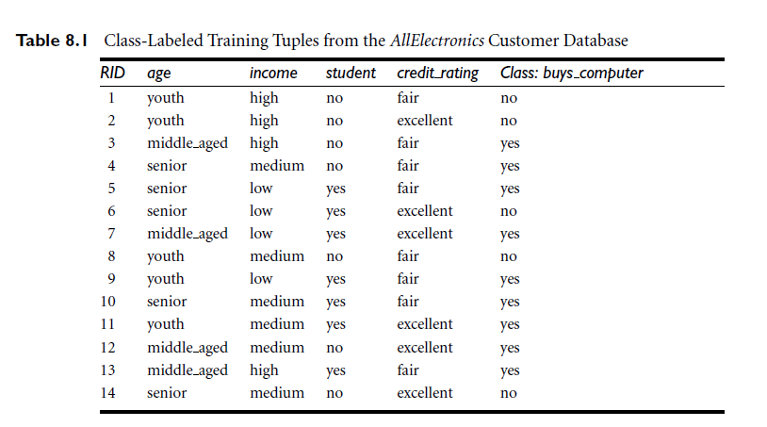

Exercise

**1. Compute Entropy and Information Gain (ID3)**

* Calculate the **Entropy** of the dataset.
* Compute **Information Gain** for each attribute.
* Identify the **best attribute for splitting** based on Information Gain.
* Manually construct the first few levels of the **ID3 Decision Tree**.

**2. Compute Gini Impurity (CART)**

* Compute the **Gini Impurity** for each attribute.
* Identify the **best attribute for splitting** based on the lowest Gini Index.
* Manually construct the first few levels of the **CART Decision Tree**.

**3. Implement ID3 and CART in Python**

* Write a Python function to compute Entropy, Information Gain, and select the best attribute for splitting (ID3).
* Write a Python function to compute Gini Impurity and select the best attribute for splitting (CART).
* Construct a Decision Tree from scratch without using DecisionTreeClassifier.

**4. Compare ID3 vs. CART**

1. Which attribute was chosen first in ID3? Why?
2. Which attribute was chosen first in CART? Why?
3. How do the resulting decision trees differ?
4. Which method is better when dealing with continuous variables?